1.) circular linked list (structure in class).cpp (output)

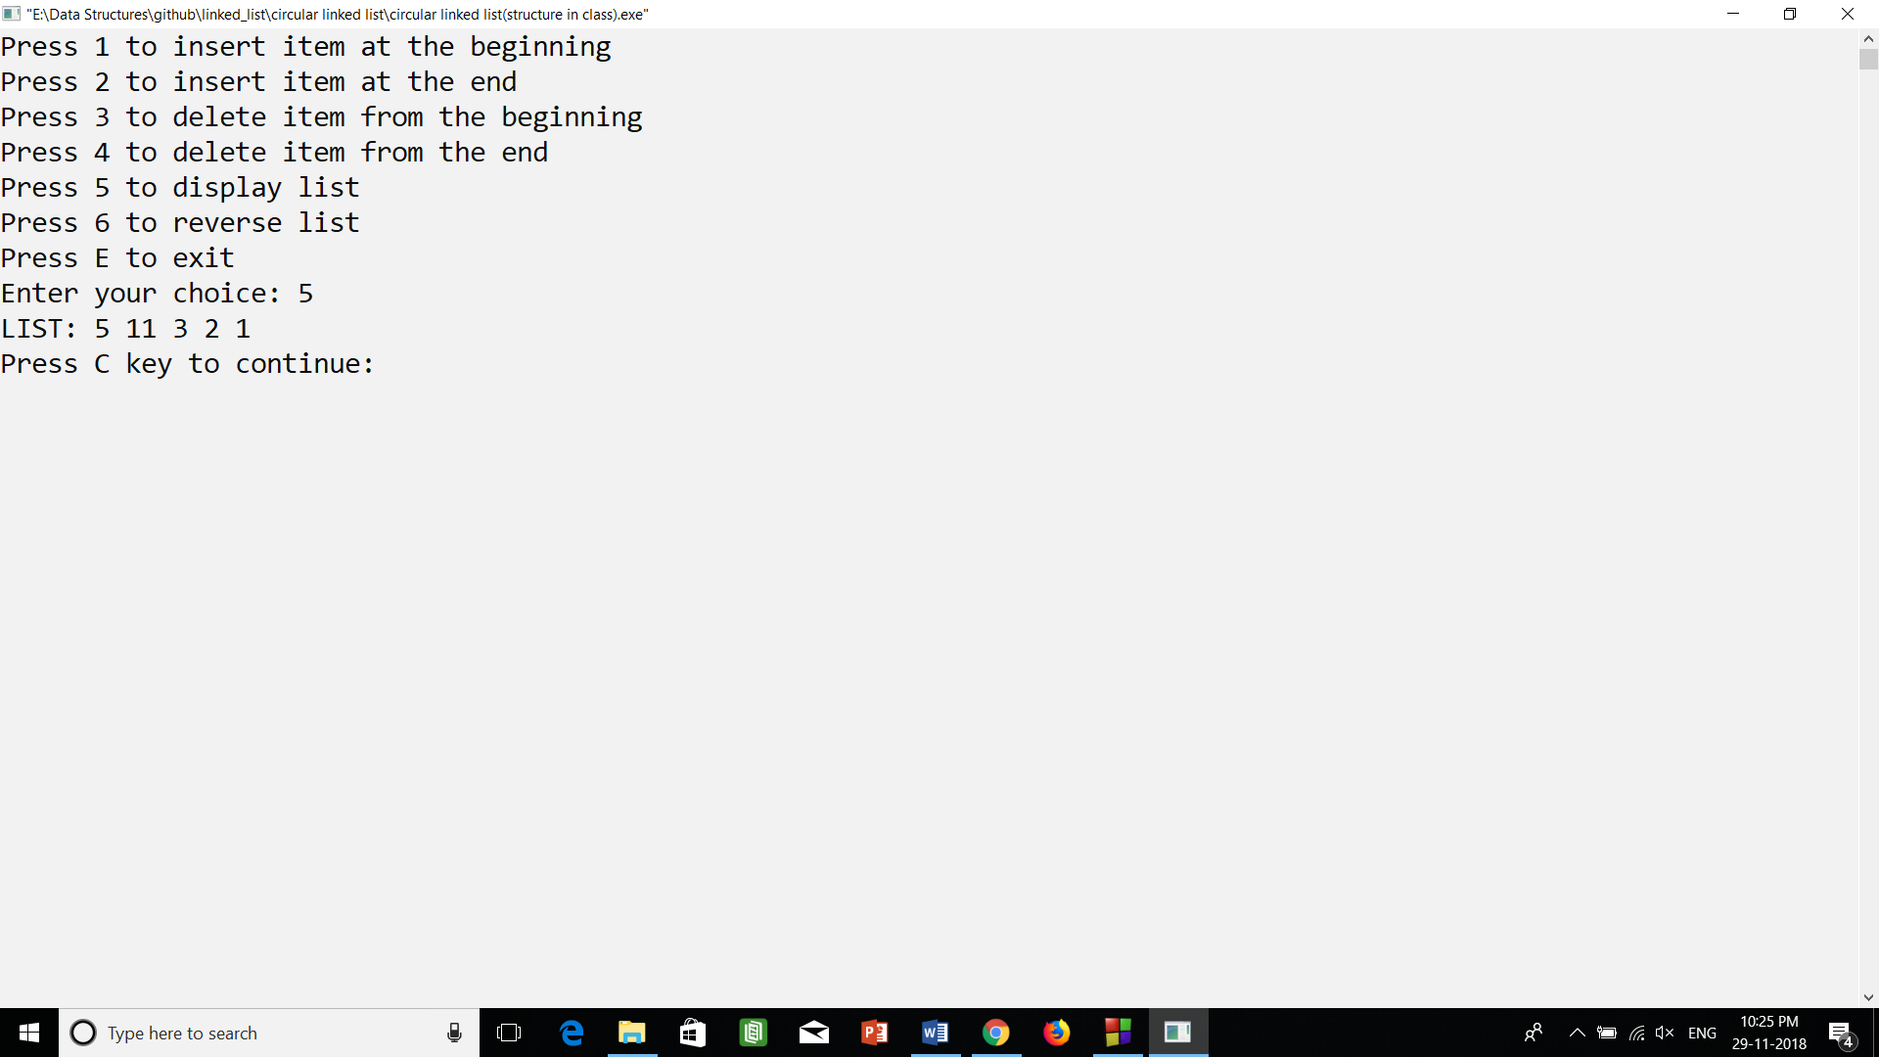

2.) circular linked list (using class).cpp (output)

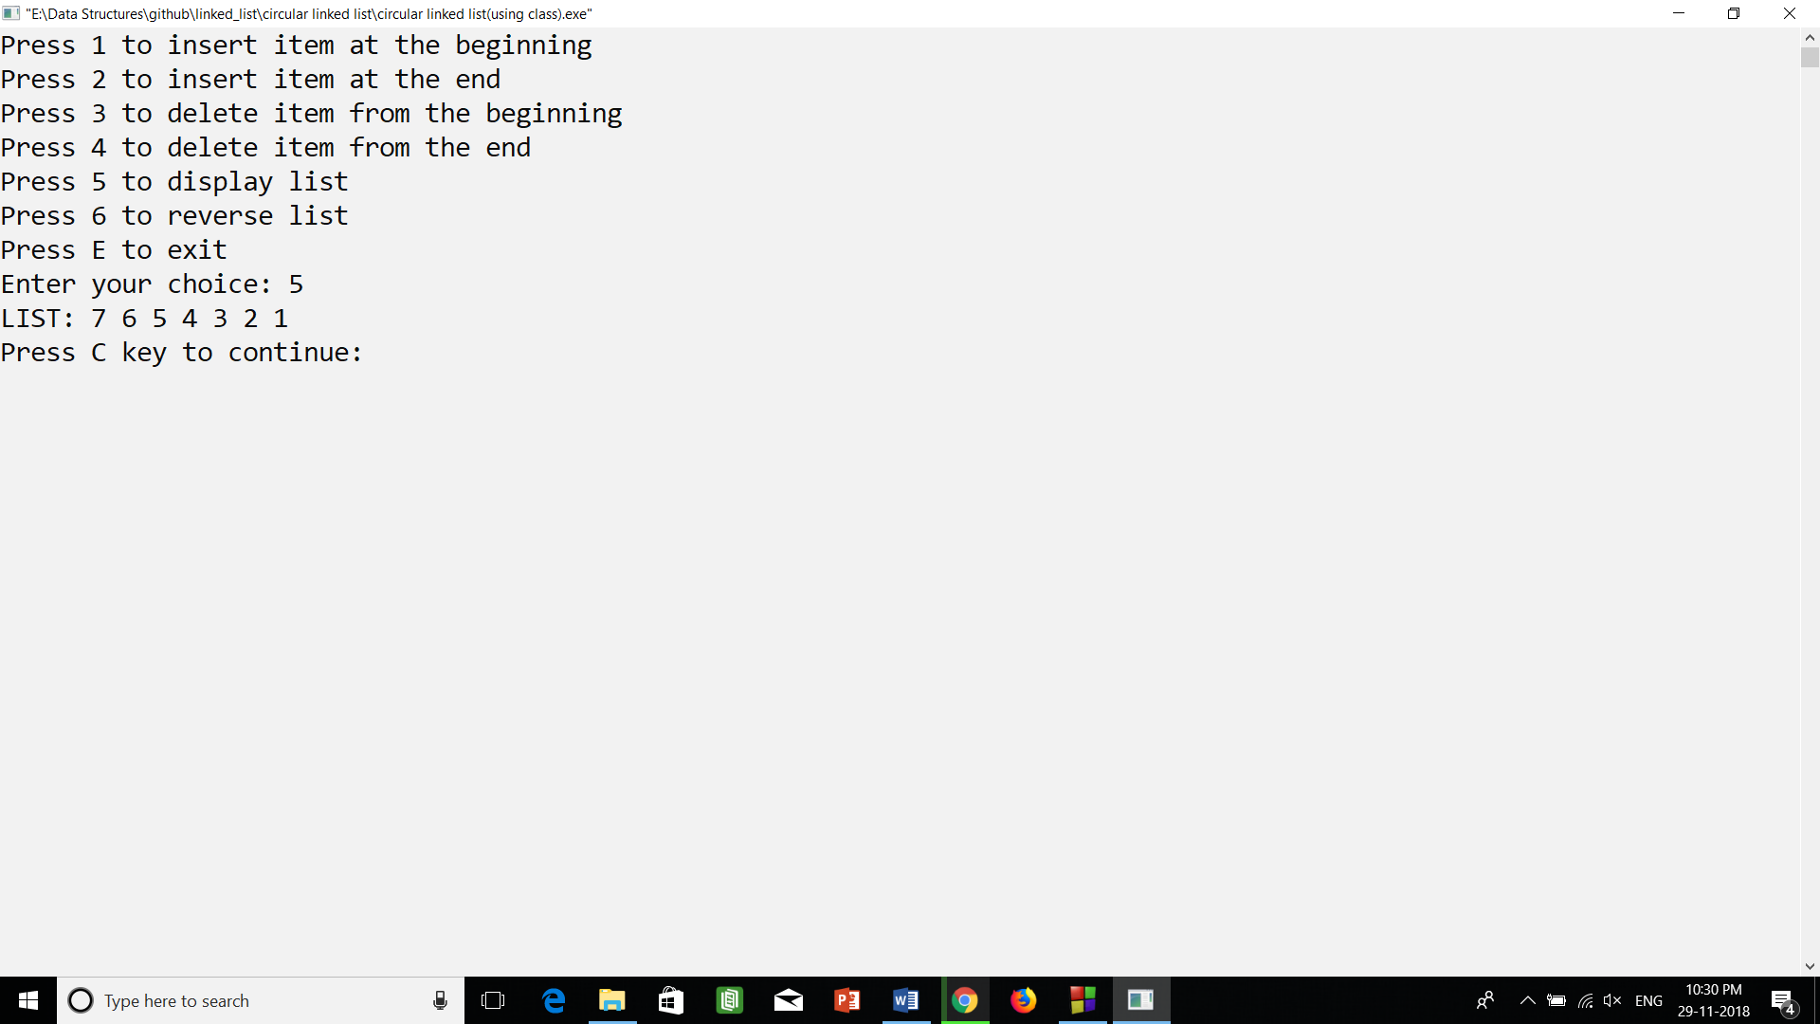

3.) circular linked list (using struct and class).cpp (output)

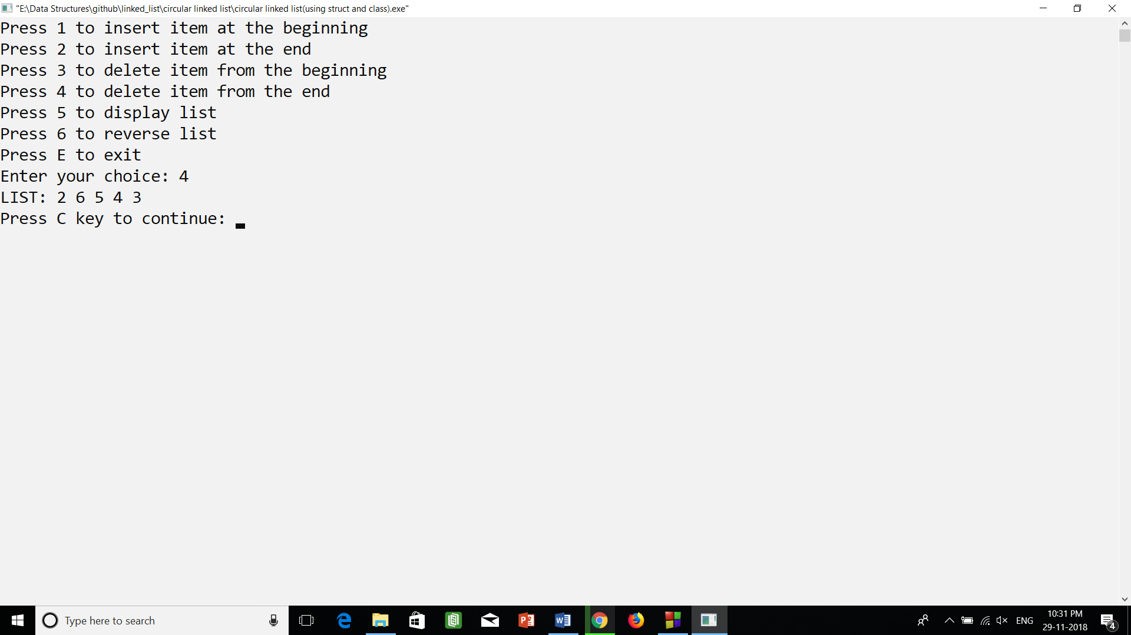

4.) circular linked list.cpp (output)

